Nyra Bug -09/04/2026

- Aeps -> registration->we showing Bank account number and IFSC code also but not the bank name.

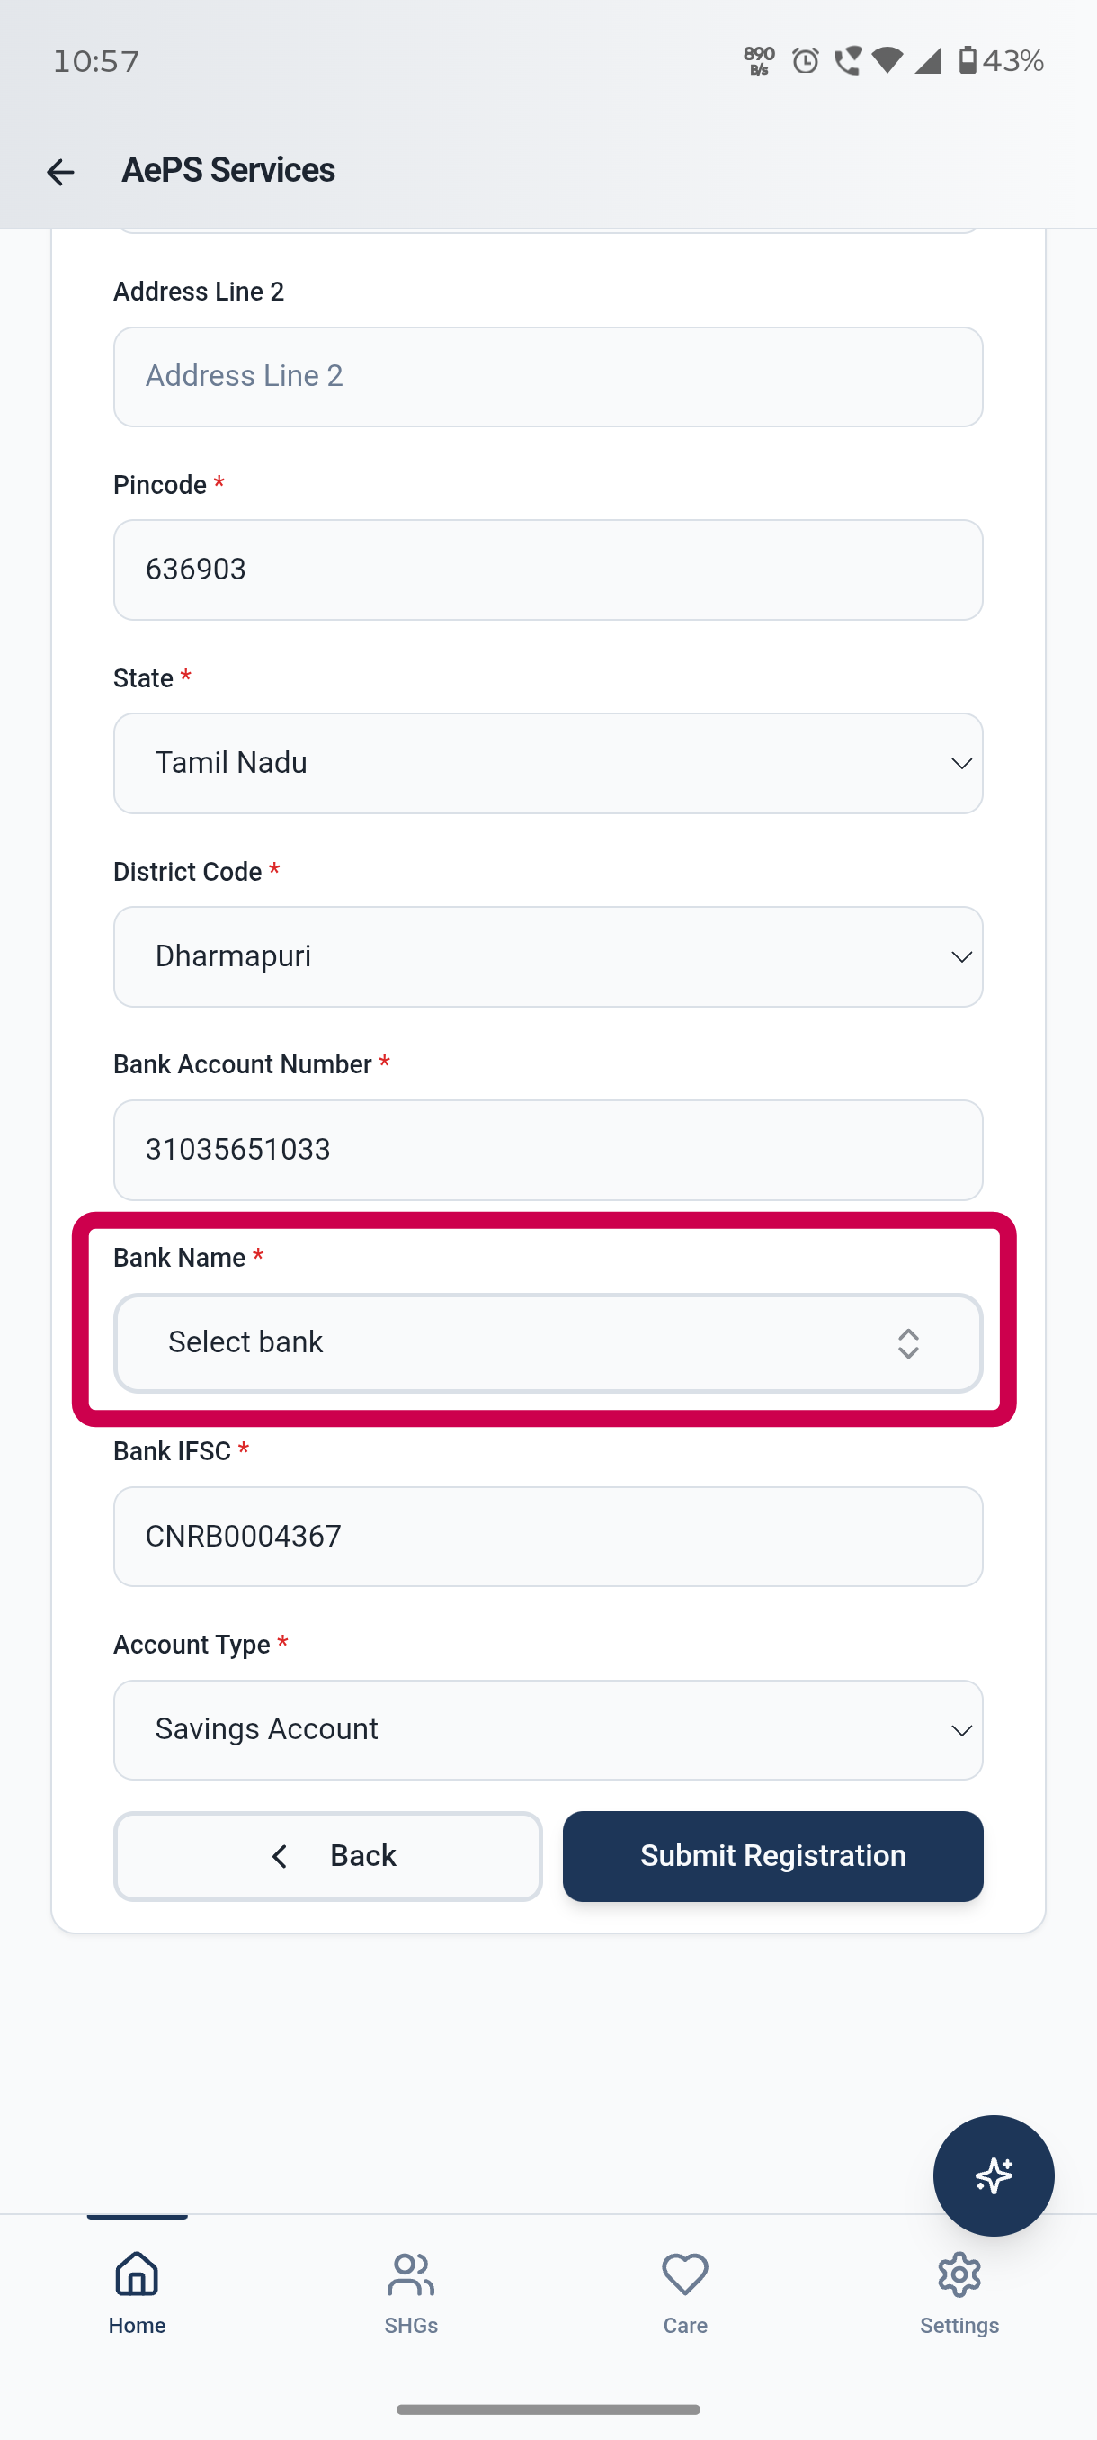

- SHG login-> member add step->I uploaded the pan and vote id for the member but I checked in the draft uploaded pan and vote document is not showing.

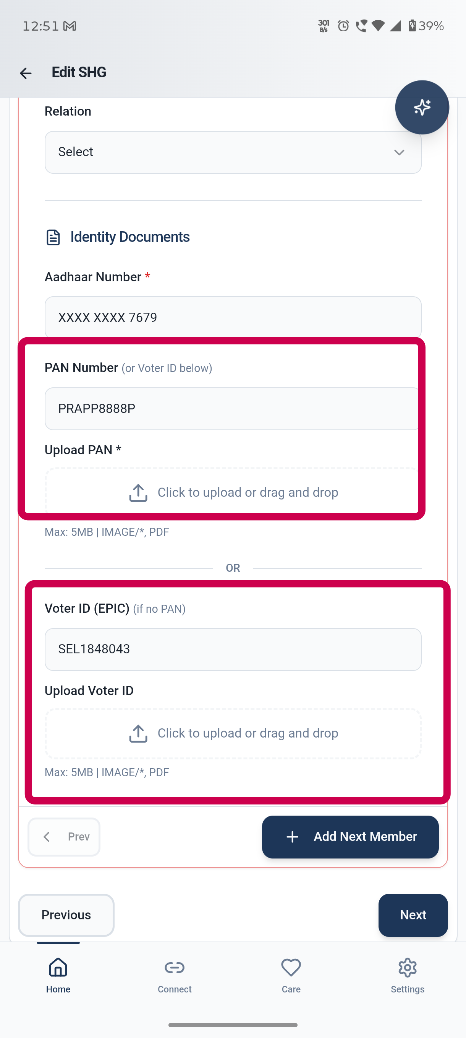

- Agent login ->settings ->service Agreement ->Agent photo is not showing in the service Agreement document.

